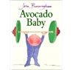 | 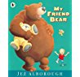 | 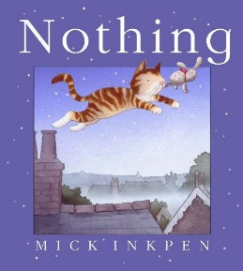 | 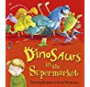
Avocado Baby by John Burningham | My Friend Bear by Jez Alborough | Nothing by Mick Inkpen | Dinosaurs in the Supermarket by Timothy Knapman

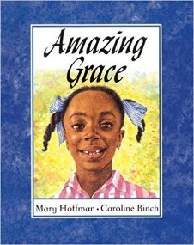 | 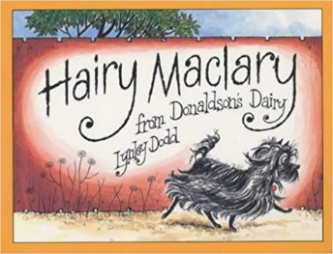 | 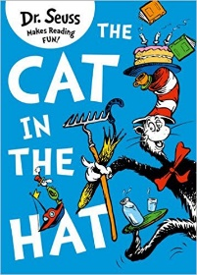 | 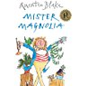
Amazing Grace by Mary Hoffman | Hairy Maclary by Lynley Dodd | The Cat in the Hat by Dr Seuss | Mr Magnolia by Quentin Blake
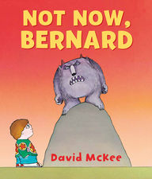 | 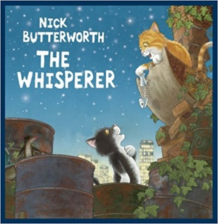 | 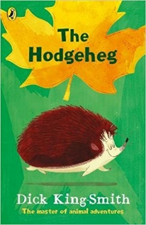 | 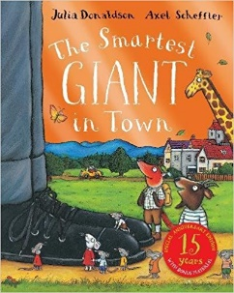
Not now Bernard by David Mckee | The Whisperer by Nick Butterworth | The Hodgeheg by Dick King-Smith | The Smartest Giant in Town by Julia Donaldson

