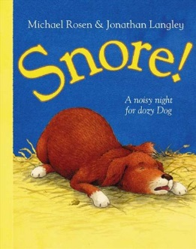 | 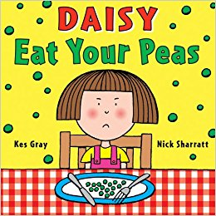 | 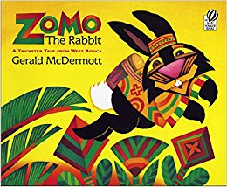
Snore  By Michael Rosen | Daisy Eat your peas  By Kes Gray | Zomo the Rabbit  By Gerald McDermott

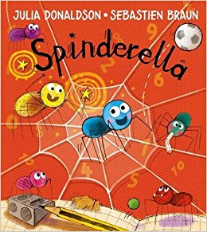 | 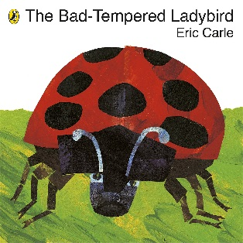 | 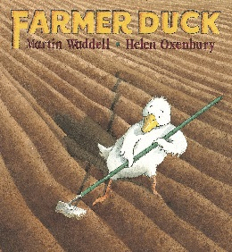
Spinderella  By Julia Donaldson | The Bad-Tempered Ladybird  By Eric Carle | Farmer Duck  By Martin Waddell
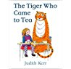 |  | 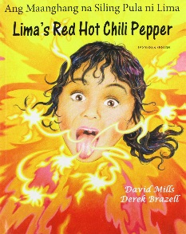
The Tiger who came to Tea  By Judith Kerr | Mr Wolf’s Pancakes  By Jan Fearnley | Lima’s Red Hot Chiil  By David Mills

